**Portfolio Project – BlackJack**

**Patrick Valera**

1. Introduction

For my python portfolio project, I decided to program a blackjack game. It’s a player vs dealer table where the player starts with a 1000 credit, placing a bet before each round. The game ends once the player is out of credit. The dealer is automated and will keep drawing until its hand value is 17 or more.

Features:

* A betting system
* Program detects if the player gets a Blackjack (Face card + Ace card)
* An ASCII graphical interface that represents a Jackblack table.
* Player vs. Automated dealer

2. Design and Implementation

The software that runs the game is Object Oriented. It consists of 4 different classes (Blackjack, Hand, Card, Deck) with their own attributes and methods, Blackjack class being the longest in terms of code length. The program takes input from the player via the terminal and executes a code block depending on the input. The game features a simple graphical interface in the terminal. Parts of the interface is highlighted with color to distinguish parts of the game.

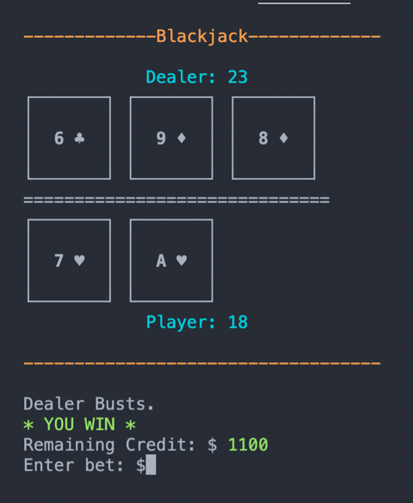

3. Conclusions

This project was a great learning experience for me. Python is my third language and this project made me more comfortable working in python, its modules, and the different methods of each data type. Although, I still found myself looking up solutions on stackoverflow, mostly about the different modules in python such as *os*, *random* and *time*.

I think the best feature is the terminal interface which shows the jackblack table. Some terminal texts are also highlighted which makes the outputs nicer to look at.

In a real game of blackjack, the ace has two values – 1 or 11, which makes a hand have two different values. In my game an ace card only has one value – 11. This is a feature that could be added in the future.